**Unit 5 - Worksheet 5**

**Forces in 2 Dimensions**

1. An applied force of 25N pushes on a 5.0 kg block resting on a frictionless horizontal surface. The force is directed parallel to the surface.

1. Draw a force diagram for the block.
2. Determine the force of gravity on the block.
3. Determine the normal force on the block.
4. Determine the acceleration of the block.

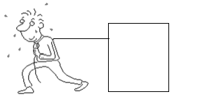

1. A 75.0 kg box is pulled by a 400 N force parallel to the horizontal flat surface. If the block is accelerated at 2.0 m/s/s, determine the force of friction on the block.
2. If the string snapped… what would happen?